Open a Repair Order in ROM-Customer Unit: This topic covers how to open a repair order in Repair Order Maintenance (ROM) for unit brought in by a customer.

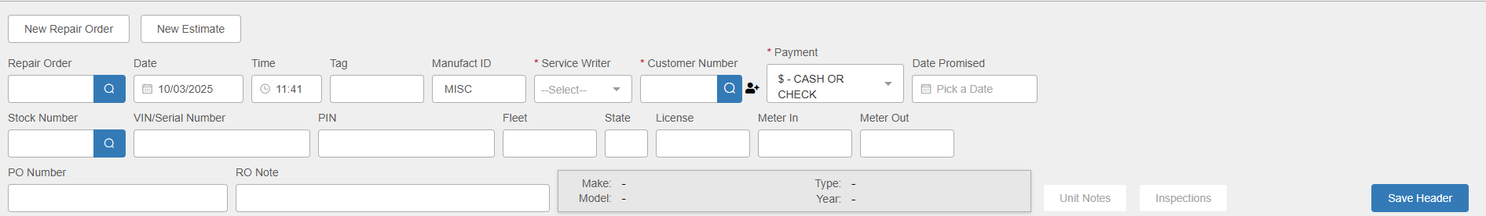

New Repair Order: ROM should be set to begin a new repair order as soon as you open the program, but you can always click this button at any point to start a new order. NOTE: If you want to create an estimate rather than an RO, click New Estimate instead and follow the same steps.

Header Fields:

Repair Order: This field will hold the RO number. You only need to fill in a new RO number if you do not have your system set to auto-assign RO numbers, or if you have a paper RO that already has an assigned number on it. If you have the auto-assign function turned on in Service Options & Defaults (SOD), the field will automatically fill in with a number once you finish creating the header. NOTE: You can also use the field to look up and open an existing repair order.

Date: This field will default to the current date, but you may change it by entering a new date or selecting one from a calendar.

Time: This field will default to the time when you started creating the new order, but you may change it by entering a new time in the field. The clock is set to military time (1-24 instead of 1-12), and the field will reject any entry that does not represent an actual time of day.

Tag: This field is currently an informational field only – not required.

Manufact ID: This field holds the manufacturer ID for the unit being repaired. It defaults to “MISC.”

Service Writer: Type in the service writer’s ID or select it using the dropdown.

Customer Number: Enter the customer’s number here or look it up using the Search function. If the customer is not found, you can use the New Customer icon next to the field to create a record for the customer. NOTE: If you see a pop-up box of open repair orders for this customer such as the one below, click the Start New RO button to bypass it.
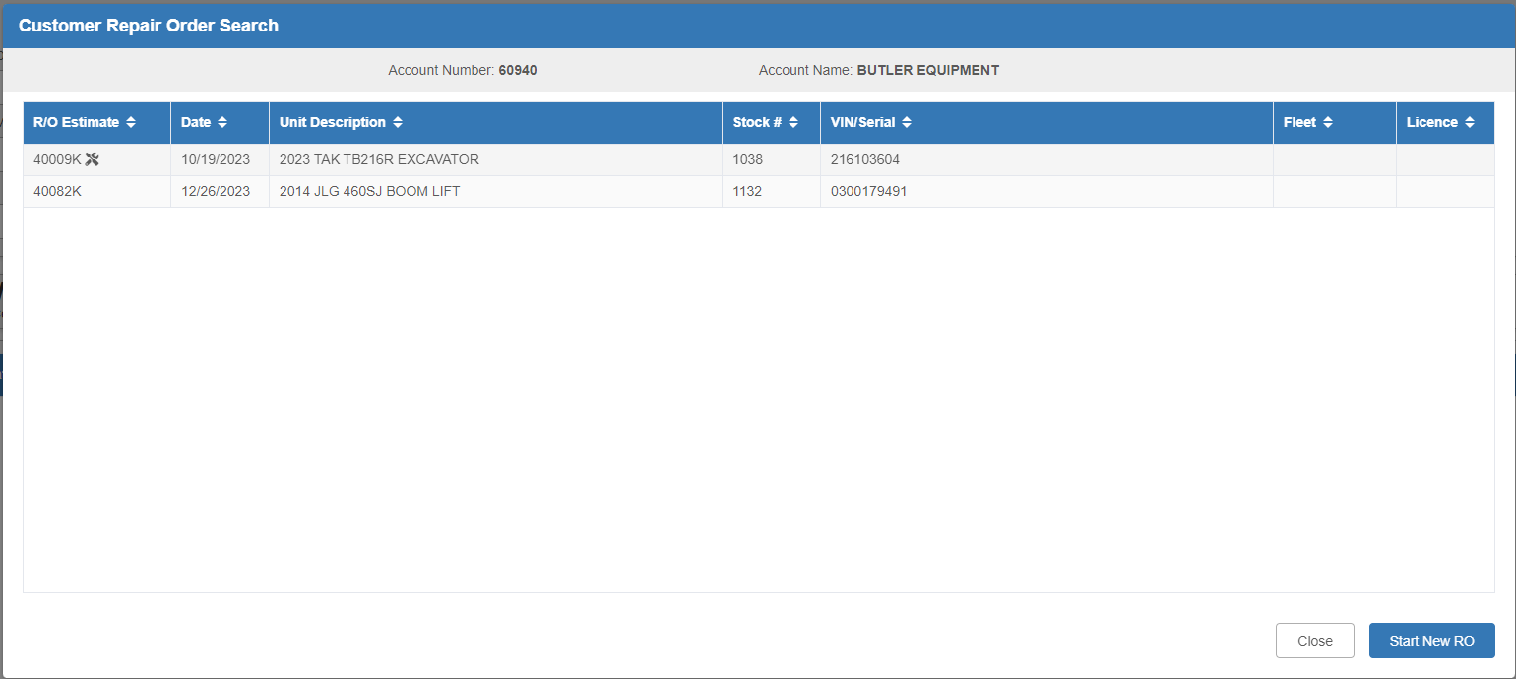

Payment: The Method of Payment (MOP) defaults based on the customer’s Master record in Enter Customer Information (ECI). This is only a suggested payment option. During Settlement, you will still have the chance to change it, though you need to have one selected in the Header to create the RO.

Date Promised: If your dealership’s policy is to set a promise or target date for repair completion, you can enter that date in this field. If entered, it will print on Tech Copy and Invoice. You can otherwise leave it blank.

Stock Number: Enter the Stock Number if known or use the Search function to look one up. If you have already selected the customer at this point, the Search button will open Customer Equipment Maintenance (CEM) to let you see only units belonging to the selected customer. If the unit is not already on record, you will be able to use this screen to add it.

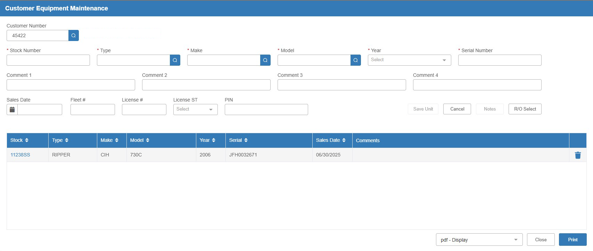

VIN/Serial Number: This field is not required, but you can enter the unit’s VIN or serial number here.

PIN: If the unit has or requires a PIN number, enter it in this field.

Fleet, ST, and License: These fields are currently informational fields only – not required.

Meter In/Out: Enter information in these fields as required by your dealership’s policies and/or system settings. These will print on Tech Copy and Invoice.

PO Number: Enter a purchase order number here if needed.

RO Note: Add a short note here if desired.

Make/Model/Type/Year: These fields will automatically fill in if you select a unit for the RO.

Unit Notes: This button will activate once you select a unit for the RO. It will let you view the unit’s notes as recorded in the system.

Inspections: Clicking this button will redirect you to the Record360 login page. Once you log in with your Record360 credentials, you will be able to view any inspections for the unit recorded in the Record360 system.

Save Header: Press this button to save the header information. The Repair Order number has been assigned (you will see the field grayed out to prevent you as the user from changing it). The Header will also now change to its locked status:

Click Edit Header at any time to unlock the header and make any needed changes.

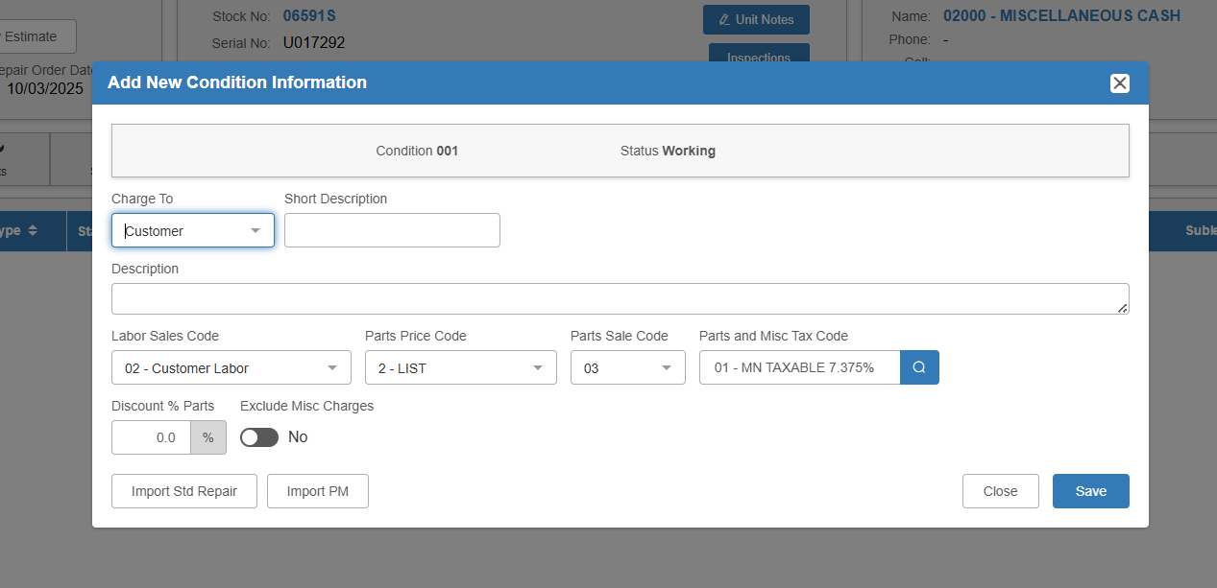

Add New Condition: This screen automatically opens when you initially create a new repair order. Fill it in to create the first condition on the RO.

Charge To: Make sure this is set to Customer.

Short Description: Fill in a brief description of the repair needed.

Description: You may fill in more details of the repair needed if desired.

Codes: These codes will default from the Customer Master. Change/select only if needed. The codes are:

- Labor Sales Code
- Parts Price Code
- Parts Sales Code
- Parts and Misc Tax Code

Discount % Parts: Only fill this field if applicable to the RO.

Exclude Misc Charges: Set this to “Yes” only if you do not want to allow miscellaneous charges on this condition.

Save: Click this button to save the repair description and create the condition.
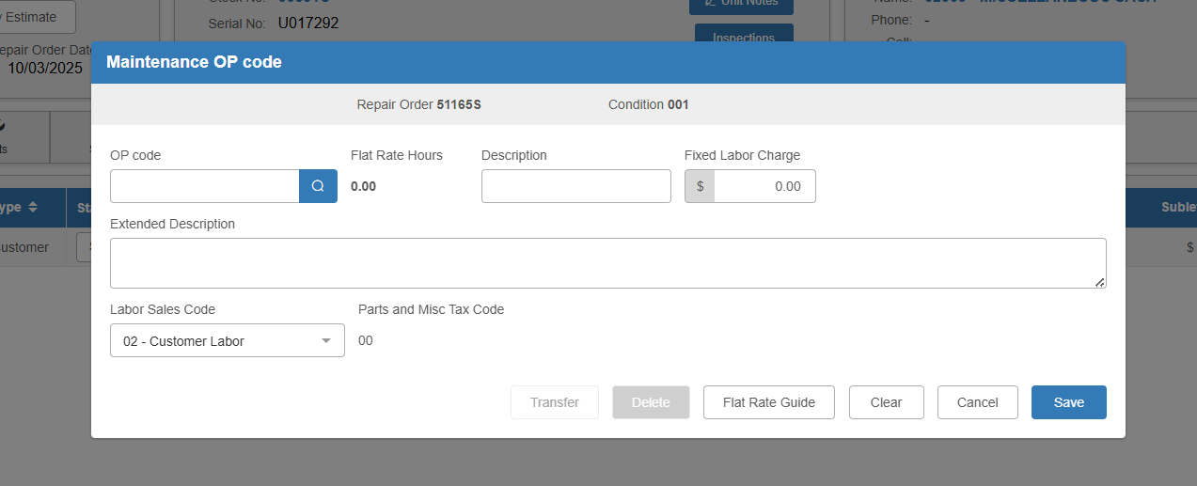

OP Code: This window will automatically open once you have created your first condition. It allows you to set an OP code for the condition. Type in the code or use the Search button to select one from the OP Code Search:

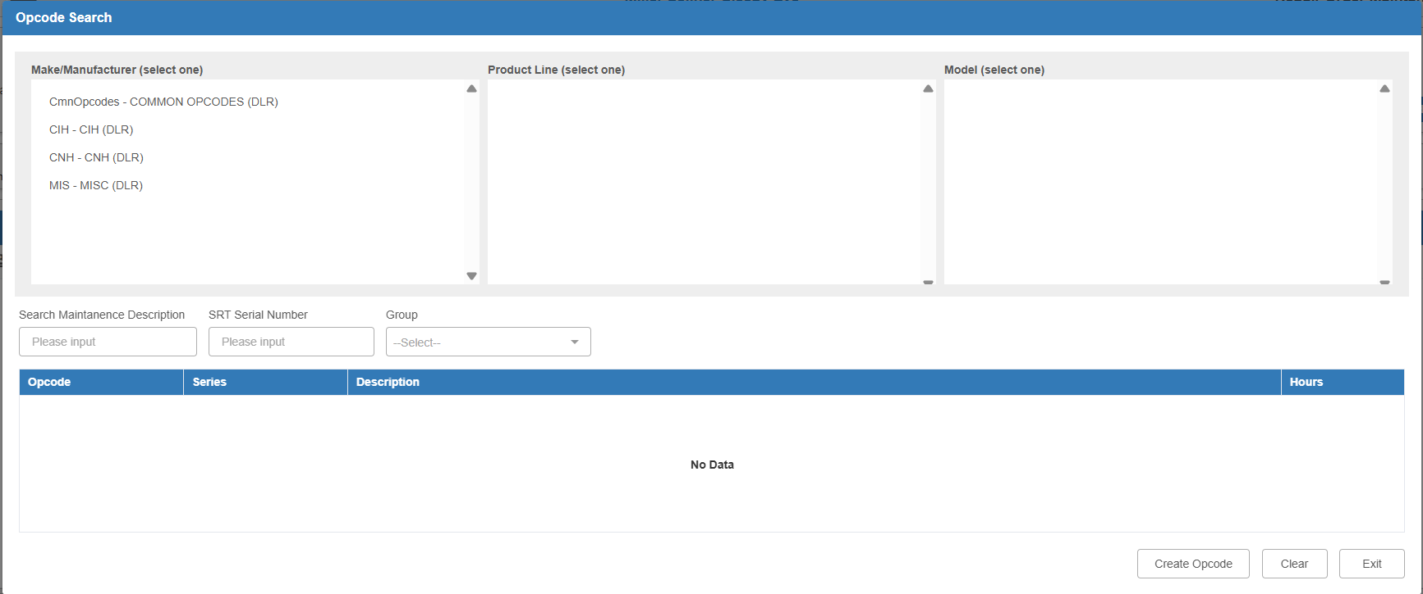

You will want to use the Common Opcodes (DLR) Make/Manufacturer for most of your OP codes.

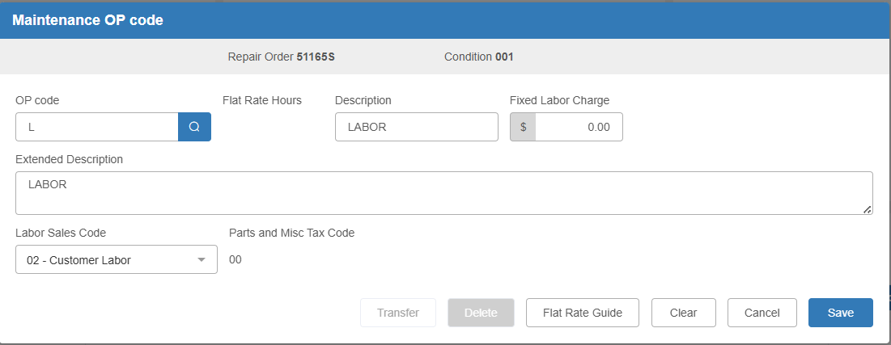

After you choose your desired code, its information will automatically fill in the rest of the screen.

Fixed Labor Charge: If desired, you can assign a fixed labor amount to the OP code here. If you leave this field at $0.00, your technician’s time slips will be used to calculate the labor cost.

Save: Click this button to save the OP code to the condition.

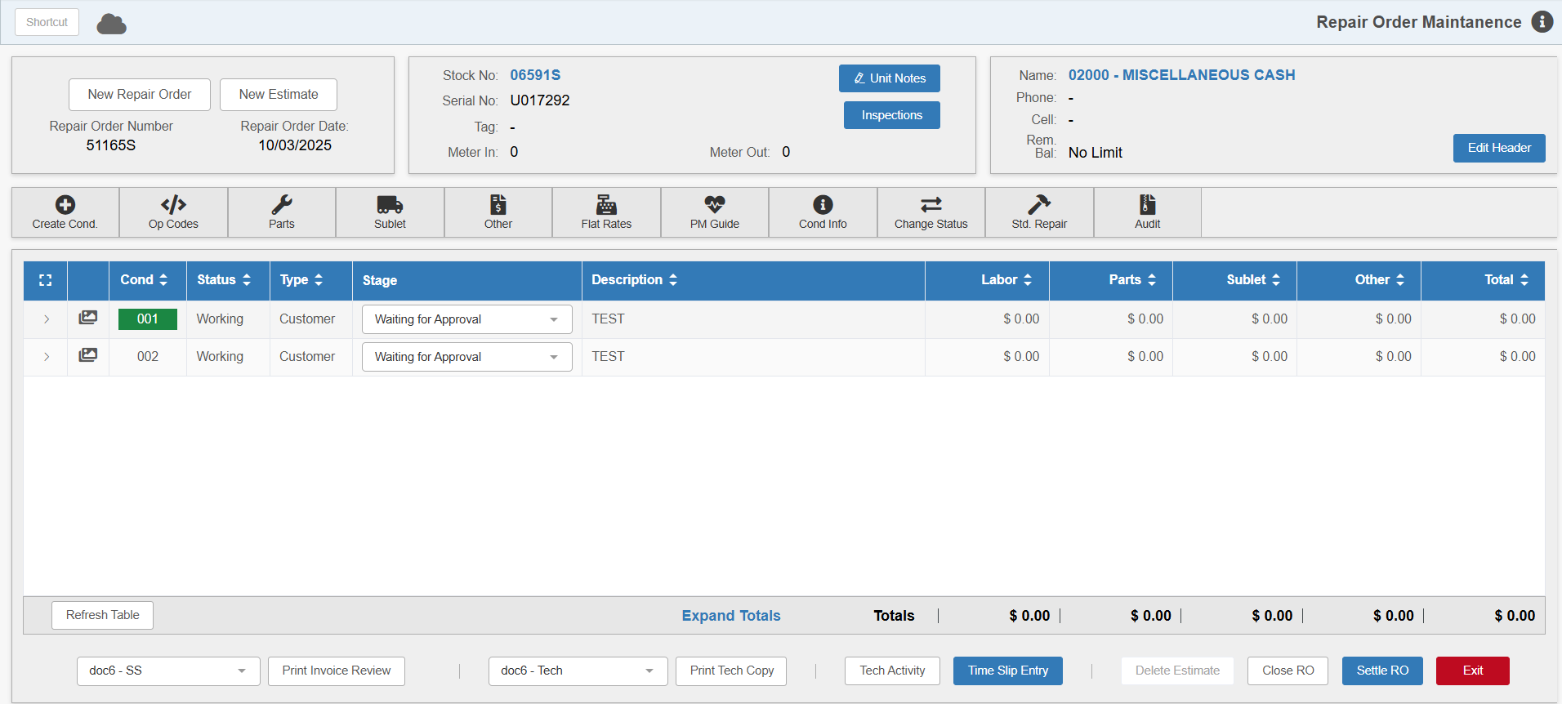

Add as many conditions as needed to the RO in order to complete it. Once you add a condition, your technicians will be able to start working on it.

Stage: If your dealership has Stages set up in SOD, the default starting Stage will automatically be assigned to the RO. You can then modify the Stage as the RO is processed to provide additional information on the condition’s status at any given time.

Condition Images: If you want to add pictures to a condition, click the  icon on the left side of the condition to open the Condition Image Upload screen:

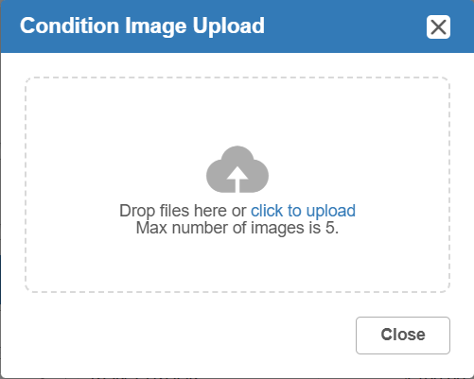

You can add up to 5 image files either by dropping them in this screen or by using the “click to upload” hyperlink to find and add them from your computer. After you add images to the condition, the icon will change to show how many images you have attached, like so: 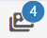. You can then open this screen at any time to view and adjust what images are attached.

Printing the RO: Print the Tech Copy (Hard Copy) by clicking on the Print Tech Copy button. It will print to the selected printer

